SUPPORT LIFE CHANGING ADVENTURE:
SCOUT YOUTH FOUNDATION

SYF Membership and Supporter form

Please complete and email to syf@scouts.org.nz or print and post to PO Box 11348 Wellington 6142
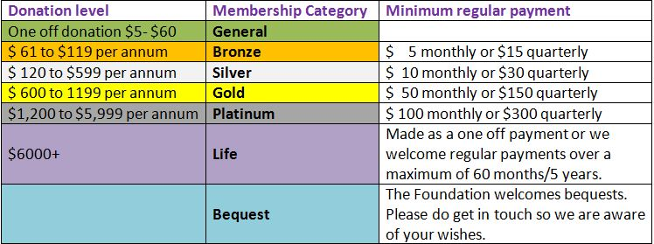

One off donations and additional gifts are welcome, by internet bank payment or cheque.
Your contributions are tax deductible and will be receipted at the end of each tax year.
Internet banking payments to: Scout Youth Foundation account: 06-0501-0623599-00
Please put: Membership Number or New Member in reference line, your name as Particulars, and your membership category under Code. For regular givers, a membership reference number will be issued to include as reference for your continuing regular giving payments.

Contact the Foundation via syf@scouts.org.nz, phone 64 (0)4 815 9260, or check online on www.scouts.org.nz/about-us/support-us
----------------------------------------------------------------------------------
JOIN & SUPPORT THE SCOUT YOUTH FOUNDATION
REGISTERED UNDER THE CHARITABLE TRUSTS ACT 1957 CHARITIES COMMISSION REGISTRATION CC11451
Please complete this form and save as pdf or Word doc & email to syf@scouts.org.nz
or print and post to PO Box 11348 Wellington 6142
These details enable us to say thank you, and issue an end of year tax donation receipt

Your title, first & last names
Your address | Email:  Postal:
Your gift or membership category (please delete what doesn’t apply) | I am joining as a Bronze/ Silver/ Gold/Platinum/ Life member  OR I am making a one off donation of _________as a General member  OR I am interested in becoming a Bequest member
Your first donation amount | $_____________  I will pay by Automatic payment/ Cheque (Delete what doesn’t apply)
How you are making your gift  (Please delete what doesn’t apply) | Internet banking:  I have set up an automatic payment of $______  to be paid monthly/ quarterly/ six monthly/ annually starting on date __/__/___  OR I have made a one off on line payment of ______________  OR I enclose a cheque for $___________

